Policy Name | Publishing of Journal Policy
Proposed By | Director ORIC
Reviewed By | Registrar and Pro-VC
Approved By | ORIC Steering Committee
Effective From | 01-07-2026
Next Review Date | 30-06-2028
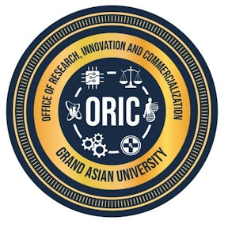
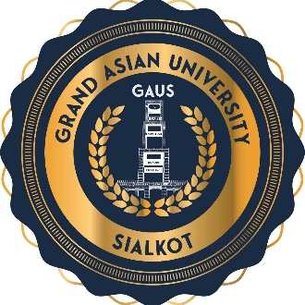

- Preamble
Grand Asian University (GAUS) recognizes scholarly journals as strategic platforms for disseminating original research, advancing knowledge, and enhancing the University's national and international academic reputation. This Policy establishes the governance, quality assurance framework, editorial standards, ethical principles, and indexing roadmap for all journals published under the auspices of Islam Group and Grand Asian University. It is aligned with the requirements of the Higher Education Commission (HEC) of Pakistan, the Directory of Open Access Journals (DOAJ), and internationally recognized best practices in scholarly publishing.
- Objectives
The University shall:
- Publish high-quality peer-reviewed scholarly journals.
- Achieve and maintain HEC recognition.
- Obtain indexing in internationally recognized databases.
- Enhance the visibility and citation of research published by GAUS.
- Attract national and international authors, reviewers, and editors.
No journal shall be launched under the Islam Group or University's name without approval from the competent authority.
- Governance Structure
Each journal shall have:
- Patron In Chief (Chairman)
- Patron (Vice Chancellor)
- Editor-in-Chief
- Managing Editor
- Editorial Board Editorial board and Advisory board comprising members with PhD degrees in relevant fields (i.e., area of publication) or FCPS/FRCS/MCPS degree for medical journals and strong research and publications background. Editorial and Advisory boards are separate entities.
- Reviewers Panel

- Quality Standers
To strengthen the quality every journal published under the name of Islam Group or University shall comply to these minimum quality standards. The use of Open Journal Systems (OJS) or an equivalent manuscript management system shall be mandatory, consistent with HEC requirements. Editors, reviewers, and authors shall comply with internationally accepted publication ethics, and journals should adopt policies consistent with the Committee on Publication Ethics (COPE).
- Publish original scholarly work.
- Operate a rigorous double-blind peer review system.
- Use a recognized online journal management platform (e.g., Open Journal Systems).
- Publish on a regular schedule.
- Maintain editorial independence.
- Follow international publication ethics.
- Screen all submissions for plagiarism.
- Assign Digital Object Identifiers (DOIs) to published articles.
- Presence of Ethical Statements
- Editorial Affiliation Details
- Author Affiliation Details
- Appropriate Citations to Literature
- Open Access Policy
GAUS supports responsible Open Access publishing. Journals should align with the Principles of Transparency and Best Practice in Scholarly Publishing, which are expected for inclusion in DOAJ.
- Full-text articles shall be freely accessible online.
- Authors shall retain rights as specified by journal policy.
- Copyright and licensing information shall be clearly displayed.
- Article Processing Charges (if any) shall be transparently declared.

- HEC Compliance
All GAUS journals shall comply with the latest HEC Journals and Publications Policy, including requirements such as:
- Valid ISSN registration.
- Clearly defined aims and scope.
- Functional journal website with online archives.
- Transparent editorial and peer-review processes.
- Publication of a minimum number of quality research articles per issue.
- Qualified and independent editorial and advisory boards.
- Ethical publishing policies.
- Use of OJS or an equivalent manuscript management system.
- Regular and timely publication schedules.

- Journal Indexing Roadmap
The University shall progressively pursue indexing in recognized databases. Each journal shall prepare an annual indexing improvement plan
Phase I (Years 1–2) | - HEC Journal Recognition  - Crossref (DOI registration)  - Google Scholar
Phase II (Years 2–4) | - DOAJ  - EBSCO (subject to eligibility)  - ProQuest (where applicable)
Phase III (Years 4–6) | - Scopus  - Web of Science (ESCI)
Phase IV (Years 6–10) | - Science Citation Index Expanded (SCIE)  - Social Sciences Citation Index (SSCI)  - Arts & Humanities Citation Index (AHCI)

- Institutional Facilitation
Responsibility of regular publishing and maintaining the journal lies with the Managing Editor. Editor in Chief will be an honorary position. Every Managing Editor shall get a waiver of one course for the coming year on successful publication of the volume and issues of the current journal. However, they can seek assistance for the following from ORIC, Treasurer, and Social Media team.
Task | Relevant Office
Coordinate journal development | ORIC
Facilitate indexing applications | ORIC
Conduct quality audits | ORIC
OJS hosting and maintenance | IT
Website development | IT
XML production | IT
Journal promotion and marketing | Social Media Team
- Policy Review and Amendments
This policy shall be reviewed every two years, or earlier if required, to ensure alignment with the University's strategic priorities, HEC regulations, emerging technologies, and international best practices. Amendments shall be approved by the appropriate statutory bodies of the University.
Proposed By: Approved By:

Director ORIC Vice Chancellor/ Chairman ORIC-SC
Grand Asian University Sialkot Grand Asian University Sialkot

